Worksheet for

Lab Zero: A First Experiment Using GENI

Slice Name: lab0<your initials>

Login to nodes:

Client login: ssh ________@__________________ -p _______

If not specified,

port defaults to 22

Server login: ssh ________@__________________ -p _______

If not specified,

port defaults to 22

Fill in the blanks in the diagram below:

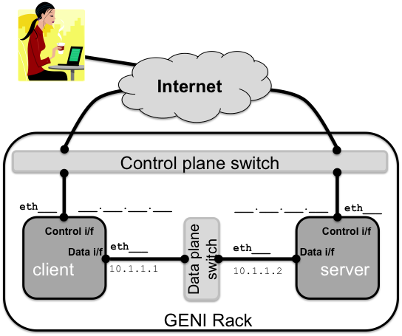

Don’t forget to delete your resources!

