Worksheet for

Lab Zero: A First Experiment Using GENI

Project Name: <TBD>
Slice Name: lab0<your initials>

Aggregate: NYSERNet InstaGENI (aka instageni.nysernet.org)

Login to nodes:

Client login: ssh ________@__________________ -p _______

Server login: ssh ________@__________________ -p _______

Fill in the blanks in the diagram below:

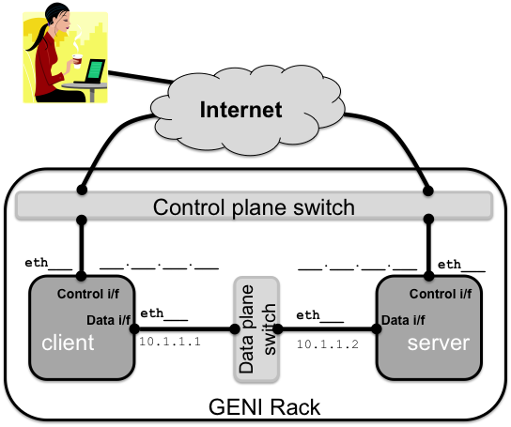

Don’t forget to delete your resources!

Worksheet for

Lab Zero: A First Experiment Using GENI

Project Name: <TBD>
Slice Name: lab0<your initials>

Aggregate: Missouri InstaGENI (aka instageni.rnet.missouri.edu)

Login to nodes:

Client login: ssh ________@__________________ -p _______

Server login: ssh ________@__________________ -p _______

Fill in the blanks in the diagram below:

Don’t forget to delete your resources!

Worksheet for

Lab Zero: A First Experiment Using GENI

Project Name: <TBD>
Slice Name: lab0<your initials>

Aggregate: Illinois InstaGENI (aka instageni.illinois.edu)

Login to nodes:

Client login: ssh ________@__________________ -p _______

Server login: ssh ________@__________________ -p _______

Fill in the blanks in the diagram below:

Don’t forget to delete your resources!

Worksheet for

Lab Zero: A First Experiment Using GENI

Project Name: <TBD>
Slice Name: lab0<your initials>

Aggregate: Clemson InstaGENI (aka instageni.clemson.edu)

Login to nodes:

Client login: ssh ________@__________________ -p _______

Server login: ssh ________@__________________ -p _______

Fill in the blanks in the diagram below:

Don’t forget to delete your resources!

