G E N I
Global Environment for Network Innovations

GEC 10 ERM Status Report

Document ID: GEC10_ERM_Status_Report_Mar10

March 17, 2011

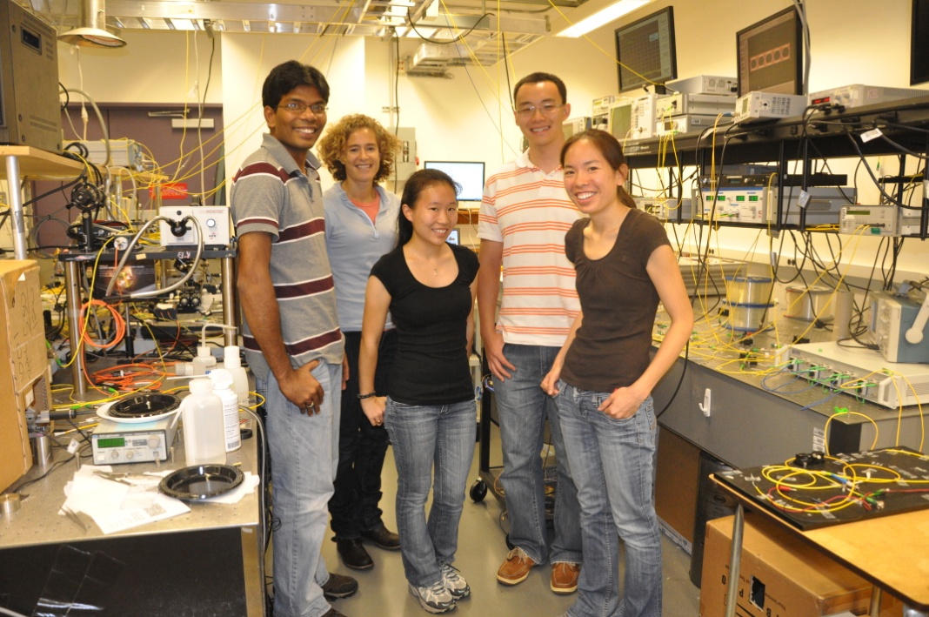

Prepared by:
M.S. Wang, B.G. Bathula, C. Chen, and K. Bergman
Dept. of Electrical Engineering, Columbia University New York,
500 W. 120th Street,
New York City, NY 10027
under Project Nr. 1631
“Embedding real-time measurements for cross-layer communications”

Document Revision History
The following table provides the revision history for this document, summarizing the date at which it was revised, who revised it, and a brief summary of the changes. This list is maintained in chronological order so the earliest version comes first in the list.

Revision | Date | Revised By | Summary of Changes
1.0 | 17 Mar 11 | M.S. Wang | Initial draft

Embedding real-time substrate measurements for cross-layer communications
GENI Quarterly Status Report
Project Nr.: 1631

P.I. Keren Bergman
Department of Electrical Engineering, Columbia University, New York

1. Major accomplishments

During this past quarter, our main accomplishments involved the completion of milestones S3.c and S3.d.
The goal of milestone S3.c involved the demonstration of two deliverables at GEC10. The first deliverable was the design and development of a more robust, universally deployable version of the UMF (called the ‘ERM Box’). At GEC 10, we showcased the architecture of the ERM Box and highlighted it ability to connect to the perfSONAR standard framework to obtain real-time optical layer measurements, and further use this measurement capability to enable cross-layer control. The second deliverable involved developing a simulation environment with networking model incorporating the ERM Box and cross-layer measurement capabilities enabling experimental modeling in large scale networks. We demonstration the simulation results at GEC 10.
The goal of milestone S3.d includes the documentation and release of source code. The NetFPGA [netfpga_1] HW source code and simulation source code are released on the ERM Wikipage [erm_1].

2. Milestones
The following section discusses the progress made on the spiral 3 milestones for ERM:

Milestone S3.a: Demonstration at GEC9 and Experimenter Outreach (completed 11/5/2010)
- Presented poster at the demo session that summarized the spiral 1 & 2 achievements and described the spiral 3 goals and roadmap.
- Presented an updated video tutorial of the existing ERM capabilities within BEN at the demo session.
Milestone S3.b: Documentation and Code Release (completed 11/20/2010)
- Reported the progress made in spirals 1 & 2; presented the roadmap for achieving the spiral 3 milestones. Updated on wiki as ERM GEC9 QSR.

Milestone S3.c: Demonstration at GEC10 and Experimenter Outreach (completed 3/17/2011)
- Design and develop a robust, universally deployable version of the UMF (called the ‘ERM Box’) consisting of:
  - A suite of software and NetFPGA code to expand the optical layer measurement capabilities
  - A set of active optical components (SOAs, VOAs, etc) to enable cross-layer control
The design of this box will integrate the needs and requirements of current GENI infrastructures, instrumentation/measurement platforms, our primary plan is to integrate with PerfSONAR.

- Develop simulation environment with networking model incorporating the ERM Box and cross-layer measurement capabilities enabling experimental modeling in large scale networks.
Milestone S3.d: Documentation and Code Release (completed 4/5/2011)
- Submit the architectural design, including PCB layouts, hardware source codes, and software releases related to the ERM Box.
- Submit the simulation source code and results.

Milestone S3.e: Demonstration at GEC11 and Experimenter Outreach (due 7/31/2011)
- Deploy multiple ERM boxes (between 2 to 4) within suitable GENI infrastructures that can most take advantage of real-time optical layer measurement and cross-layer control. Potential GENI infrastructures include the BEN network located in North Carolina (where we have already been working during spiral 2) and the DRAGON/MAX network located in the greater Washington D.C. area.

- Conduct an experiment using this ERM-enabled network involving non-GENI researchers. We have already initiated these projects with collaborators at AT&T Research and Lucent/Alcatel. Potential issues that ERM could address are:

  - Restoration and Protection: IP-layer restoration is becoming an important issue for the networking community. We can utilize the ERM box to monitor the IP traffic on the WDM network. ERM box can be enabled with functionalities to restore and protect IP router failures, by intelligently rerouting the traffic on the optical layer.
  - Energy Efficiency: The increasing number of networking devices in the present day Internet is causing a significant rise in the energy consumption. The ERM box can be used to enable traffic engineering (TE) based on energy-efficient routing. For example, the routing algorithm could minimize the number of IP ports used by enabling optical bypass.
Milestone S3.f: Documentation and Code Release (due 8/15/2011)
- Describe the infrastructures in which the ERM boxes were deployed, and what special requirements these infrastructures required.
- Submit the source code used in running the experiment. Demonstrate the accessibility of the ERM box by non-GENI researchers to conduct experiments.
- Further, summarize the achievements made in the earlier milestones.
3. Deliverables made
- ERM Milestone S3.c (March 2011)
- ERM Milestone S3.d (March 2011)

4. Description of work performed during last quarter
- Organizational work
Working with the GPO (specifically Harry Mussman), details regarding our ongoing work and our contributions to GENI Spiral 3 were released on the GENI ERM Wikipage; this includes quarterly reports and the Milestones S3.c and S3.d technical notes. We have also participated in several Cluster D and GENI IMF [imf_1] meetings through teleconference.

- A Robust, Universally Deployable ERM Box

Building off the work done in developing a NetFPGA-based Unified Measurement Framework (UMF), our next step is to design and develop a robust, universally deployable version of the UMF (called the ‘ERM Box’) consisting of:
- A suite of software and NetFPGA code to expand the optical layer measurement capabilities
- A set of active optical components (SOAs, VOAs, etc) to enable cross-layer control

The design of this box will integrate the needs and requirements of current GENI infrastructures. As the figure above shows, the existing GENI platforms that the ERM Box can interface with includes the
- Fujitsu FlashWave 9500 Reconfigurable optical add-drop multiplexer (ROADM)
- Infinera Digital Transport Node (DTN) [infinera_1]
- Polatis Optical Cross-Connect (OXC) [polatis_1]
- Specially designed optical performance monitor (OPM) developed by DRAGON/MAX network
The ERM Box uses software-based network equipment interface to retrieve optical layer measurements from these existing GENI substrates. In an effort to conform to the GENI-defined standards, we integrated the optical layer measurement capability with perfSONAR. This is done by incorporating the efforts of the IMF project, which was responsible for developing the perfSONAR Measurement Points (MPs) for the Polatis OXC and Infinera DTN platforms located in the BEN network in North Carolina.

- Network Modeling and Simulation with ERM Box Capabilities

We developed a simulation environment with networking model incorporating the ERM Box and cross-layer measurement capabilities enabling experimental modeling in large scale networks. For the simulation, we chose to use the US CORONET topology, which is a fiber-optic backbone network developed for use in the research of large-scale DWDM networks.

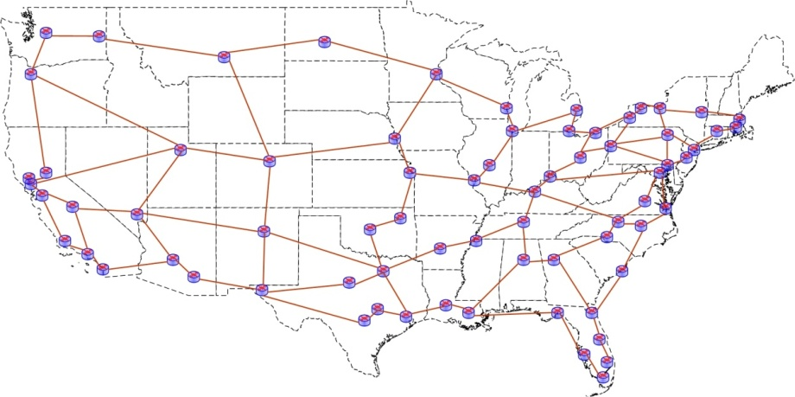
US CORONET Network Topology

ERM enabled network can route a lightpath in a energy efficient way with minimal impact on quality-of-service (QoS) constraints imposed during the connection provisioning. Routing methods for the light path include (1) Bypass (2) Non-bypass, and (3) Hybrid (or mixed) bypass.

- Visit DRAGON/MAX Network to Discuss ERM Box Integration

In December, we visited the DRAGON network (Dynamic Resource Allocation via GMPLS Optical Networks) located in the Mid-Atlantic Crossroads (MAX) [max_1] organization based in College Park, Maryland. DRAGON is an optically switched network. We visited the network just when they finished upgrading their equipments to the latest Fujitsu FlashWave 9500 ROADMs.

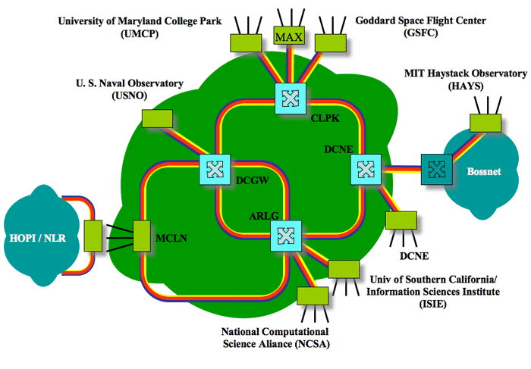
The purpose of the meeting was to look for another suitable GENI infrastructure that can take advantage of real-time optical layer measurement and cross-layer control offered by the ERM Box. The DRAGON researchers were very eager to the collaboration. The following objectives were achieved as a result of the meeting:
  - We received detailed manuals for the Fujitsu FW9500 after signing an NDA.
  - The DRAGON researcher sent us (to Columbia) a specifically-built optical performance monitor (OPM) that can measure optical power and optical signal-to-noise ratio. We are in the process of testing the device and ultimately connecting it to the ERM Box.
  - We developed a software architecture to connect the ERM Box to the Fujitsu FW9500 and OPM by GEC 11.

5. Activities and findings
5.1 simulation results

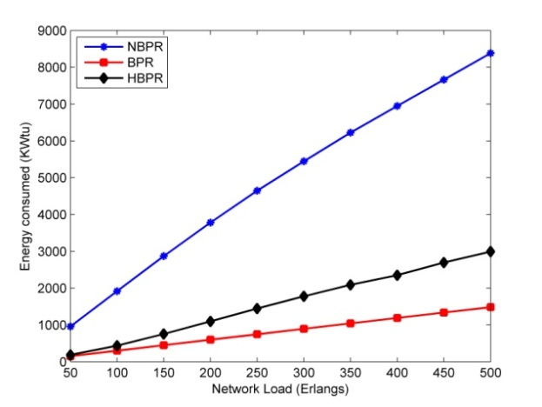

Energy consumptions in CORONET for different routing methods

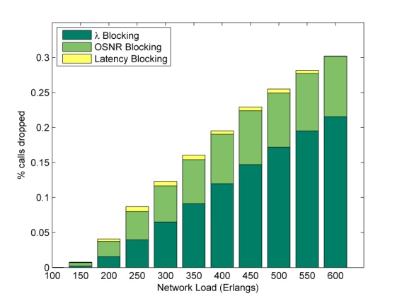
(a)
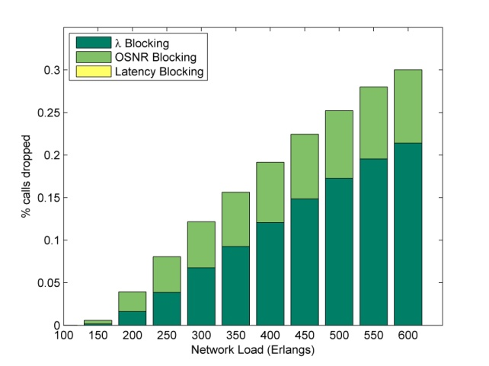
(b)
Calls blocked due to constraints such as wavelength continuity, OSNR and latency.
In (a) latency threshold is 70 ms and in (b) 100ms

6. Project participants
P.I. Keren Bergman, Columbia University New York, bergman@ee.columbia.edu
Balagangadhar Bathula, Columbia University New York, bbathula@ee.columbia.edu
Caroline P. Lai, Columbia University New York, caroline@ee.columbia.edu
Cathy Chen, Columbia University New York, cache@ee.columbia.edu
Michael S. Wang, Columbia University New York, msw2138@columbia.edu
7. Publications (individual and organizational)
- Presentation at OFC 2011 of “Demonstration of QoS-Aware Video Streaming Over a Metro-Scale Optical Network Using a Cross-Layer Architectural Design”.

8. Outreach activities
- None
9. Collaborations

- Cluster D IMF Project: Renaissance Computing Insititute (RENCI), North Caroline State University (NCSU), Ilia Baldine, Shu Huang, Rudra Dutta
We worked closely with Shu Huang and Ilia Baldine of RENCI, and Rudra Dutta of NCSU in the scope of the IMF project. More specifically, we worked with Shu Huang in developing the perfSONAR MP integration with the optical layer monitoring capabilities within the Polatis OXC and Infinera DTN in the BEN network. We hold a phone meeting once a week, and we communicate with email using an IMF mailing list.

- DRAGON/MAX

- GPO: Harry Mussman
We closely cooperated with Harry Mussman to create an updated version of the GENI Wikipage and submitting milestone reports and quarterly status reports.

10. Other Contributions
none

11. Bibliography

[1] [erm_1] GENI ERM Wiki. [Online]. Available: http://groups.geni.net/geni/wiki/ERM
[2] [ben_1] BEN main homepage. [Online]. Available: https://ben.renci.org/
[3] [max_1] GENI MAX wikipage. [Online}. Available: http://groups.geni.net/geni/wiki/Mid-Atlantic%20Crossroads
[4] [imf_1] GENI IMF Wiki. [Online]. Available: http://groups.geni.net/geni/wiki/IMF
[5] [netfpga_1] NetFPGA website. [Online]. Available: http://www.netfpga.org/
[6] [polatis_1] Polatis main homepage. [Online]. Available: http://www.polatis.com/
[7] [infinera_1] Infinera DTN [Online]. Available: http://www.infinera.com/products/DTN.html

