**G E N I**

Global Environment for Network Innovations

**ERM Final Report**

Document ID: ERM_Final_Report

September 15, 2011

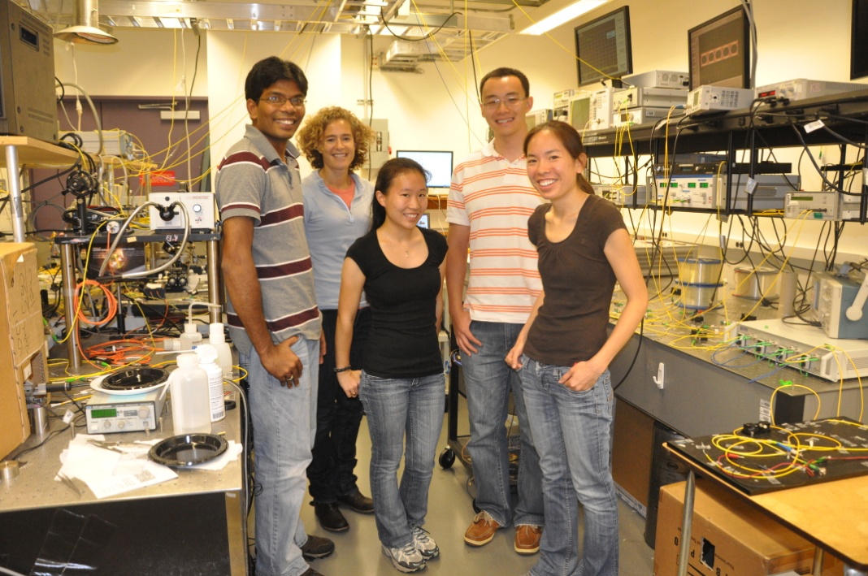

Prepared by:

M.S. Wang, B.G. Bathula, C. Chen, and K. Bergman

Dept. of Electrical Engineering, Columbia University New York,

500 W. 120th Street,

New York City, NY 10027

under Project Nr. 1631

“Embedding real-time measurements for cross-layer communications”

Document Revision History

The following table provides the revision history for this document, summarizing the date at which it was revised, who revised it, and a brief summary of the changes. This list is maintained in chronological order so the earliest version comes first in the list.

|  |  |  |  |
| --- | --- | --- | --- |
| Revision | Date | Revised By | Summary of Changes |
| 1.0 | 15 Sep 11 | M.S. Wang | Initial draft |

***Embedding real-time substrate measurements for cross-layer communications***

GENI Quarterly Status Report

Project Nr.: 1631

*P.I. Keren Bergman*

*Department of Electrical Engineering, Columbia University, New York*

**1. Major accomplishments**

During this past quarter, our main accomplishment has been working on Milestone S3.e and the completion of Milestone S3.f.

The goal of milestone S3.e involved the demonstration of two deliverables at GEC11. However, the demo session was cancelled for GEC11, and as a result, no demo was presented. The first deliverable was the deployment of the ERM Box beyond the BEN network. We have worked by deploying an ERM Box in the DRAGON network located in Maryland. This effort is still ongoing, and we expect to continue the collaboration between Columbia University and the DRAGON network beyond the ERM project. The second deliverable involved developing an experiment that highlights the advantages of the ERM Box in assisting optical networking research. We have designed such an experiment to be run on the DRAGON network, and this effort is still ongoing.

The goal of milestone S3.f includes the documentation and release of source code. The NetFPGA [netfpga_1] HW source code and simulation source code are released on the ERM Wikipage [erm_1].

**2. Milestones**

The following section discusses the progress made on the spiral 3 milestones for ERM:

***Milestone S3.a:*** ***Demonstration at GEC9 and Experimenter Outreach (completed 11/5/2010)***

* Presented poster at the demo session that summarized the spiral 1 & 2 achievements and described the spiral 3 goals and roadmap.
* Presented an updated video tutorial of the existing ERM capabilities within BEN at the demo session.

***Milestone S3.b: Documentation and Code Release (completed 11/20/2010)***

* Reported the progress made in spirals 1 & 2; presented the roadmap for achieving the spiral 3 milestones. Updated on wiki as ERM GEC9 QSR.

***Milestone S3.c:*** ***Demonstration at GEC10 and Experimenter Outreach (completed 3/17/2011)***

* Design and develop a robust, universally deployable version of the UMF (called the ‘ERM Box’) consisting of:
  + A suite of software and NetFPGA code to expand the optical layer measurement capabilities
  + A set of active optical components (SOAs, VOAs, etc) to enable cross-layer control

The design of this box will integrate the needs and requirements of current GENI infrastructures, instrumentation/measurement platforms, our primary plan is to integrate with PerfSONAR.

* Develop simulation environment with networking model incorporating the ERM Box and cross-layer measurement capabilities enabling experimental modeling in large scale networks.

***Milestone S3.d: Documentation and Code Release (completed 4/5/2011)***

* Submit the architectural design, including PCB layouts, hardware source codes, and software releases related to the ERM Box.
* Submit the simulation source code and results.

***Milestone S3.e:*** ***Demonstration at GEC11 and Experimenter Outreach (due 7/31/2011)***

* Deploy multiple ERM boxes (between 2 to 4) within suitable GENI infrastructures that can most take advantage of real-time optical layer measurement and cross-layer control. Potential GENI infrastructures include the BEN network located in North Carolina (where we have already been working during spiral 2) and the DRAGON/MAX network located in the greater Washington D.C. area.
* Conduct an experiment using this ERM-enabled network involving non-GENI researchers.

We have deployed an additional ERM Box into the DRAGON network. The effort to fully integrate this box into DRAGON, as well as to perform an experiment using it is still ongoing. Our collaboration with DRAGON will continue.

***Milestone S3.f: Documentation and Code Release (completed 9/15/2011)***

* Describe the infrastructures in which the ERM boxes were deployed, and what special requirements these infrastructures required.
* Submit the source code used in running the experiment. Demonstrate the accessibility of the ERM box by non-GENI researchers to conduct experiments.
* Further, summarize the achievements made in the earlier milestones.

**3. Deliverables made**

* ERM Milestone S3.e (September 2011)
  + Due to the cancellation of the GEC11 demo session, the demo was not made. However, the efforts are still ongoing.
* ERM Milestone S3.f (September 2011)

**4. Description of work performed during last quarter**

* Organizational work

Working with the GPO (specifically Harry Mussman), details regarding our ongoing work and our contributions to GENI Spiral 3 were released on the GENI ERM Wikipage. We have also participated in several Cluster D and GENI IMF [imf_1] meetings through teleconference.

* A Robust, Universally Deployable ERM Box

Building off the work done in developing a NetFPGA-based Unified Measurement Framework (UMF), our next step is to design and develop a robust, universally deployable version of the UMF (called the ‘ERM Box’) consisting of:

* A suite of software and NetFPGA code to expand the optical layer measurement capabilities
* A set of active optical components (SOAs, VOAs, etc) to enable cross-layer control

The design of this box will integrate the needs and requirements of current GENI infrastructures. As the figure above shows, the existing GENI platforms that the ERM Box can interface with includes the

* Fujitsu FlashWave 9500 Reconfigurable optical add-drop multiplexer (ROADM)
* Infinera Digital Transport Node (DTN) [infinera_1]
* Polatis Optical Cross-Connect (OXC) [polatis_1]
* Specially designed optical performance monitor (OPM) developed by DRAGON/MAX network

The ERM Box uses software-based network equipment interface to retrieve optical layer measurements from these existing GENI substrates. In an effort to conform to the GENI-defined standards, we integrated the optical layer measurement capability with perfSONAR. This is done by incorporating the efforts of the IMF project, which was responsible for developing the perfSONAR Measurement Points (MPs) for the Polatis OXC and Infinera DTN platforms located in the BEN network in North Carolina.

The ERM Box is designed to be a flexible platform that can be easily extended for continued development by GENI developers, as well as GENI users running their own experiments. The figure above of the ERM Box is the architecture diagram of what has been developed currently. In this version, the software portion of the ERM Box is used for the measurement interface to communicate with a heterogeneous set of networking equipments in GENI. The hardware portion of the ERM Box is used for actuation of various optical equipments inserted into the GENI substrate.

The diagram below offers an example of how to further extend the capability of the ERM Box.



Reducing the latency within an optical network is a major research topic. To build a cross-layer ERM Box that can make *fast* optical-layer measurements would be very useful. One can imagine building a measurement middleware on the NetFPGA hardware, which connects the networking equipments and the software-based perfSONAR framework. Different networking equipments may require different types of interfaces, ranging from Ethernet, GPIB, to RS232 serial connections. Building hardware-based drivers to communicate with these interfaces can speed up the measurement retrieval process.

* OSNR Measurement Device Insertion into DRAGON

After GEC 10, we began an effort to insert the ERM Box into the DRAGON network in Maryland. As a first step, we decided to insert an OPM device into the network that could measure OSNR. We decided to use an OSNR measurement device that is part of the Firstwave Intelligent Optical Switch (IOS) system. This system, as shown below, is a optical switch built in the early 2000s. It is essentially an earlier iteration of a ROADM. Unlike a ROADM, which can add/drop all wavelengths, this device can only add/drop a subset number of individual wavelengths.



This IOS system had an OPM module that monitored the OSNR of the signals going through the switch. This OPM device can be taken out of the IOS system, and inserted into the ERM Box to enable cross-layer control on the DRAGON network. Making this insertion requires a custom-made MOLEX connector that has proved to be very difficult to obtain. Through many phone calls and email exchanges with the original engineers that worked on the IOS system, we were finally able to obtain the right connectors. At this point, we have not yet finished connecting the ERM Box to the OPM device, but it is certainly something we plan to complete. The ERM project has helped to initiate collaboration between Columbia University and the DRAGON network that will go beyond the ERM project.

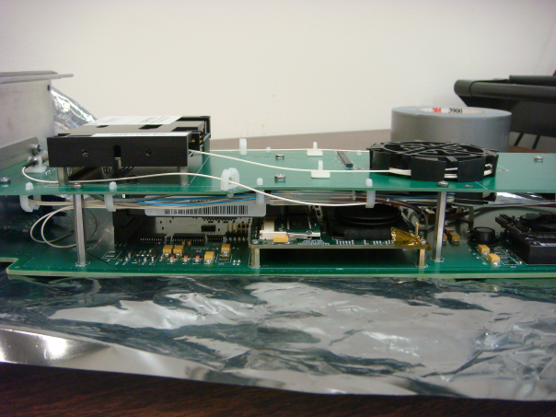

* ERM Box Insertion into DRAGON

While we worked on connecting the OSNR monitoring device into the ERM Box, we simultaneously worked on how to insert the ERM Box into the DRAGON network. The DRAGON network consists of five Fujitsu Flashwave 9500 ROADM devices. These devices provide reconfigurable wavelength switching. However, this switching is currently performed manually by a network engineer using software. Insertion of the ERM Box into DRAGON enables dynamic, real-time wavelength switching based on OSNR measurement of the signals.



**5. Activities and findings**

*5.1 NetFPGA Code Release*

The hardware portion of the ERM Box code primarily used to actuate a semiconductor optical amplifier (SOA). The code is released under the GENI ERM wikipage. This code is written using the existing netFPGA code structure. The folder structure of the netFPGA code structure is shown below.

NetFPGA2.1-x.y

|

+------ bin (contains scripts for running simulations

| and setting up the environment)

|

+------ lib (contains stable modules and common parts

| | that are needed for simulation/synthesis/design)

| |

| +---- C (contains common software and code for reference designs)

| |

| +---- verilog (contains modules and files that can be reused for design)

| |

| +---- Makefiles (various makefiles for simulation and synthesis)

| |

| +---- Perl5 (contains common libraries to interact with

| reference designs and aid in simulation)

|

+------ projects (contains user projects including the reference designs)

|

+---- geni_umf_v3_3pin

| |

| +---- src (contains all the verilog code to be used for

| | synthesis and simulation)

| |

| +---- synth (contains user .xco files to generate cores

| | and Makefile to implement the design)

| |

| +---- sw (contains all software parts for the project)

| |

| +---- include (contains files that define macros and other

| files to be included for simulation and/or synthesis)

|

+---- other netfpga projects (reference 4-port IPv4 router)

|

+---- CPCI2.1 (code for the Spartan device)

The software portion of the ERM Box primarily consists of the perfSONAR framework to monitor optical-layer performance metrics from GENI substrates. This portion of the code has been released through the IMF project.

**6. Project participants**

P.I. Keren Bergman, Columbia University New York, *bergman@ee.columbia.edu*

Balagangadhar Bathula, Columbia University New York, *bbathula@ee.columbia.edu*

Cathy Chen, Columbia University New York, *cache@ee.columbia.edu*

Michael S. Wang, Columbia University New York, *msw2138@columbia.edu*

**7. Publications (individual and organizational)**

* None

**8. Outreach activities**

* None

**9. Collaborations**

* **Cluster D IMF Project:** Renaissance Computing Insititute (RENCI), North Caroline State University (NCSU), Ilia Baldine, Shu Huang, Rudra Dutta

We worked closely with Shu Huang and Ilia Baldine of RENCI, and Rudra Dutta of NCSU in the scope of the IMF project. More specifically, we worked with Shu Huang in developing the perfSONAR MP integration with the optical layer monitoring capabilities within the Polatis OXC and Infinera DTN in the BEN network.

* **DRAGON/MAX**

We worked closely with Balasubramnia Pillai of DRAGON to obtain the OSNR monitoring device and design the process to insert the ERM Box into DRAGON. Our collaboration will continue after ERM has ended. Further, we also worked closely with Darrel Sager, who has a lot of experience in working on the OSNR module. He has helped us to obtain the necessary MOLEX connectors to connect OSNR module to the ERM Box.

* **GPO:** Harry Mussman

We closely cooperated with Harry Mussman to create an updated version of the GENI Wikipage and submitting milestone reports and quarterly status reports.

**10. Other Contributions**

none

**11. Bibliography**

[1] [erm_1] GENI ERM Wiki. [Online]. Available: <http://groups.geni.net/geni/wiki/ERM>

[2] [ben_1] BEN main homepage. [Online]. Available: <https://ben.renci.org/>

[3] [max_1] GENI MAX wikipage. [Online}. Available: <http://groups.geni.net/geni/wiki/Mid-Atlantic%20Crossroads>

[4] [imf_1] GENI IMF Wiki. [Online]. Available: <http://groups.geni.net/geni/wiki/IMF>

[5] [netfpga_1] NetFPGA website. [Online]. Available: <http://www.netfpga.org/>

[6] [polatis_1] Polatis main homepage. [Online]. Available: <http://www.polatis.com/>

[7] [infinera_1] Infinera DTN [Online]. Available: <http://www.infinera.com/products/DTN.html>